Opinion US race relations

Tulsa’s ‘Black Wall Street’ teaches us about racial economic discrimination
The eﬀects of the massacre 100 years ago still reverberate through the US today

ASHLEY HOWARD

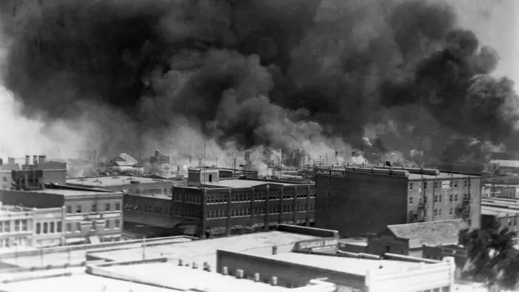
Black smoke billows from ﬁres during the 1921 Tulsa Greenwood Massacre, in the Greenwood District in Tulsa, Oklahoma © Corbis/Getty
Ashley Howard
MAY 31, 2021

The writer is assistant professor of history at the University of Iowa

One hundred years ago, white vigilantes in Tulsa, Oklahoma, raided the black Greenwood community, bursting into homes, killing occupants, looting possessions and setting structures ablaze. Scholars estimate that the crowd killed up to 300 people and that the remaining 10,000 residents were left homeless.
While the US will commemorate this event as a singular atrocity, the actions of the mob demonstrate a longstanding tradition. For black Americans, economic prosperity can prove fatal. This is harrowingly clear when we consider Tulsa’s “Black Wall Street”, home to 15 black doctors, a 55-room hotel and nearly 200 businesses.
Greenwood was self-sustaining and thriving in 1921. But it was too prosperous, too confident, too black. And as a consequence, its residents needed to be reminded, in monstrous fashion, of their rightful place in American society.

Perhaps no myth is as persistent or insidious in the US than that hard work leads to upward social mobility — the so-called American dream. To abide by this maxim, one must ignore the ways individuals, institutions and governments have for centuries conspired at all levels to suppress black prosperity. In 1892, a mob in Memphis, Tennessee mutilated and murdered three men affiliated with the black-owned People’s Grocery; days later, their main competitor purchased the store. In 1916, Anthony Crawford, the owner of 427 acres of South Carolina farmland, died at the hands of another mob after a dispute with a white shopkeeper over the price of cottonseed.
On each of these occasions, a seemingly small infraction provided the justification for violence. In actuality, the grave and intertwined affront of black economic independence, wealth accumulation and rejection of second-class citizenship signed these men’s death sentences. Since the passing of civil rights legislation 50 years ago, the black-white economic gap has remained constant. White households possess 7.8 times the median wealth of black households, and while 30 per cent of white Americans received an inheritance in 2019, only a tenth of black Americans did so.
The compounded economic effect of the Tulsa massacre still lingers today. Tulsa disallowed $1.8m in claims by black residents but compensated whites who lost property. Today, that cumulative wealth lost is estimated to be in the hundreds of millions of dollars.
This is not a singular story but a graphic example of how racial and economic discrimination are co-conspirators. Discriminatory housing policies such as redlining over mortgages, backed by the federal government, initiated decades of racist predatory behaviour including the denial of conventional home loans by banks. The exclusion of domestic and agricultural workers, disproportionately African Americans, from social security benefits eliminated their safety net. The black-white wealth gap is perpetuated by these and other practices.
Is the American dream one of bootstrapping racial reconciliation where the past can stay past and the nation sleepwalks through the present? Or is it one where we seek genuine accountability and reparations? For the three survivors of the Tulsa massacre who are still alive, financial reparations are a necessary step to ameliorate the economic impact that continues to haunt them. While the terms and amounts are negotiable, one thing is not: the money for the three survivors and descendants of Greenwood must be administered by those descendants and held in a black-owned bank.

Greenwood grew out of necessity. American apartheid blocked black people from equal opportunity. It blamed them when they did not prosper and attacked them when they did. Yet African Americans continued to work for their sliver of the American dream: full social, political and economic inclusion. The work is not over, but perhaps this is the fundamental legacy of Black Wall Street.

Copyright The Financial Times Limited 2021. All rights reserved.

